iOS APP

User´s manual
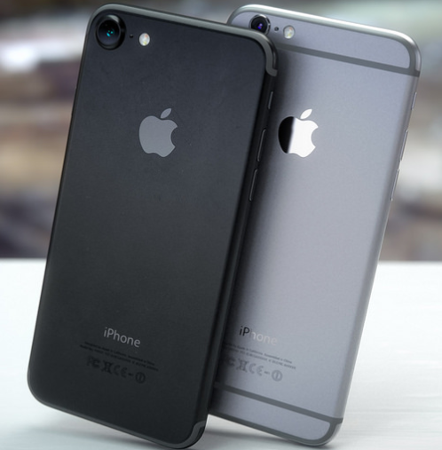

Table of contents
1. User Guide 3
1.1. Home location 3
1.2. Quick view 3
2. The MAP 3
3. Features and Tools 4
3.1. Menu Bar 4
3.2. Filter 4
3.3. Quick Button 5
3.4. Colleague Finder 5
3.5. Housekeeper and Equipment Finder 5
3.6. Create an error report: 5
3.7. Find an equipment: 6
3.8. Book a room 6

User Guide
This manual describes how to use the Flowscape billboard, what can be done and the expected results.

Home location
A click on the "Home" button takes you to the billboard´s location on the map.

Quick view
When an item is clicked, on the map or in the list view, a modal window opens (called Quick View). Depending on which item is selected, different information is visible. In the example below, the conference room Osaka has been clicked. This room is located on Floor 0, it´s a Non-bookable room in the calendar, it has 10 seats, it is equipped with Video conference and a Projector.

The MAP
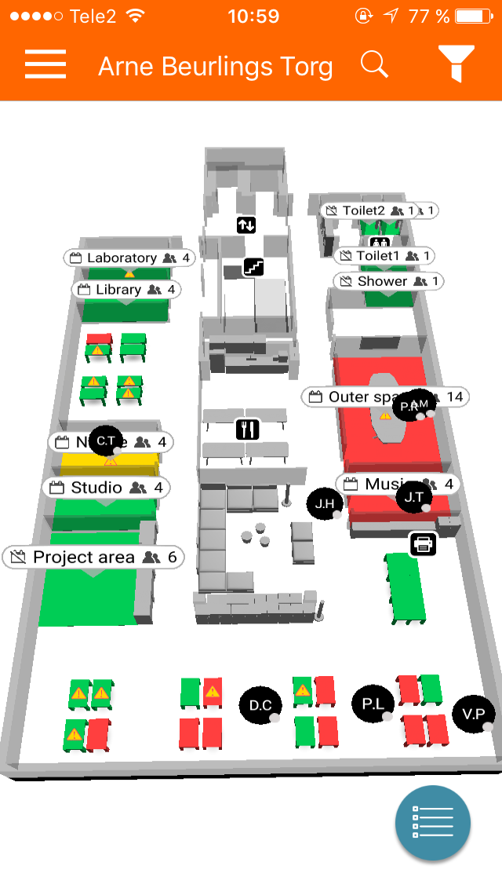
Colour indications:
- Green Available.
- Yellow Not booked, but someone is presence by a sensor. Can also be check-in time before a meeting starts.
- Red Booked
Features and tools:
- Menu bar In the upper left-hand corner.
- Select building In the top centre.
- Search field The magnifying glass
- Filter options In the upper right-hand corner.
- Quick button In the lower right-hand corner.
- Colleague finder Colleagues are shown as “black circles”
- Desk finder
- Equipment finder
- Housekeeper
- Space finder
Overview of the Flowscape IOS app.

Features and Tools

Menu Bar
In the upper right-hand corner, the menu can be accessed.
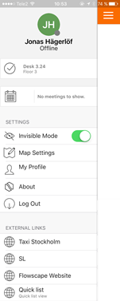
Features and tools:
- Status Indicates if online (in office) or offline (out of office).
- Reserved desk Shows which desk you are currently checked-in to.
- Upcoming meetings Show the upcoming meetings of the day.
- Visible/invisible mode By default set to invisible.
- Map settings 2D/3D view, map rotation and power saver.
- My profile Reserved desk and upcoming meetings. Able to release desk and cancel meetings.
- External links Personalize the menu bar by adding useful links, for example lunch menus.

Menu bar.

Filter
In the upper left-hand corner, the filter bar can be reached. The filter options save you time and makes it easier to find what you need.
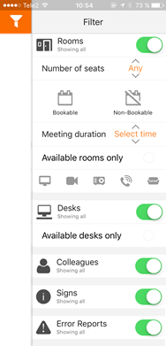
Features and tools:
- Rooms Show rooms or not.
- Number of seats Show the rooms number of seats
- Bookable/non-bookable Show if the room can be booked or not
- Duration time Depending on your chosen meeting duration time, only the available rooms will be shown.
- Available rooms only Only available rooms will be shown
- Requested equipment Chose your requirements
- Desks: Show only available desks or not.
- Colleagues Show colleagues or not.
- Signs Show signs or not.
- Error reports Show error reports or not on the map.

Filter bar.

Quick Button
In the lower right-hand corner, the Quick button or “panic” button is found. Spontaneously meetings often delay daily work for different reasons, but with the quick button the closest available meeting room to your position is shown.
Also, the problem of not finding an available desk is removed. Easily change the settings to show desk by simply click on desks instead of rooms.
Quick button icon

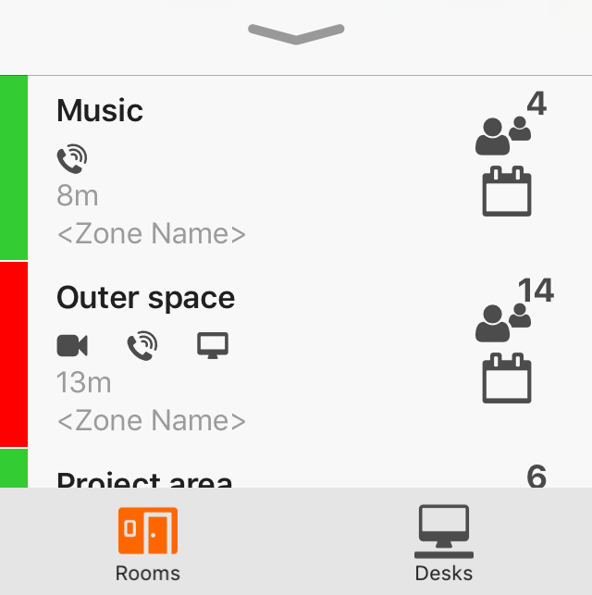
Quick view, panic button menu

Colleague Finder
By clicking on a colleague icon, a Quick view is opened. In this view, contact information and location is shown. Also, a Quick call and message button is added to minimize friction, searching for contacts in your phone catalogue. Wayfinding is available if you have got a position, marked with an arrow on the map.
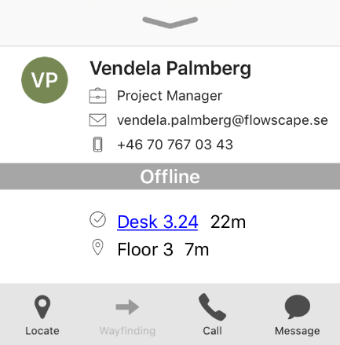
Quick view, colleague.

Housekeeper and Equipment Finder
With the Flowscape app it is easy to create an error report, whether it is an object in a room, a desk, or an equipment out in the office.
Already existing error reports are shown with error-symbols attached to the object on the map.
The Flowscape Housekeeper will help improving the error correction processes in the office.

Create an error report:
- Press on the item you want to report or if it is an object in a room or a desk, tap on that object.
- The Quick view will appear with the option “Report Error”. Tap on this button.
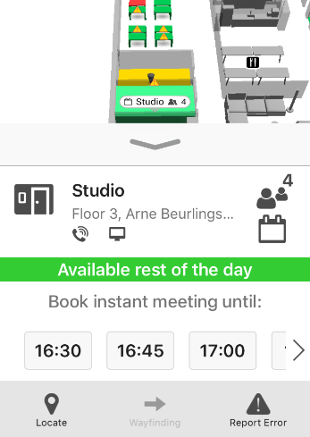
Quick view, option to report error.

- In the report, you can also attach a photo of the broken item.
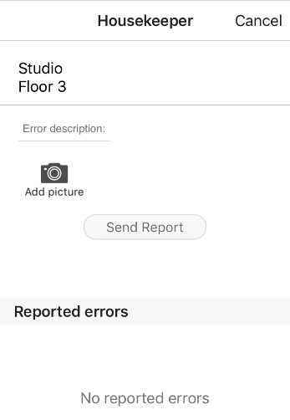
- When a description has been added, tap “Send Report” and the failure correction process can start.
Housekeeper view

Find an equipment:
- Use the search feature in the upper right-hand corner or press on the icon in the map.
- Quick view window will open and wayfinding can be chosen to show the closest route to the object.

Book a room
To create a booking, an available space is a presumption. Finding a room with the Flowscape app is easy and can be done in multiple ways.
- Search for a room in the search field, magnifying glass icon.
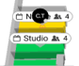
- Use the quick button to find the closest available room.
- Press on a “green room” on the map.
- Use the filters to find a room that suits your needs best, equipped with the right equipment, and with enough seats.
- When a room has been chosen the Quick view appears:
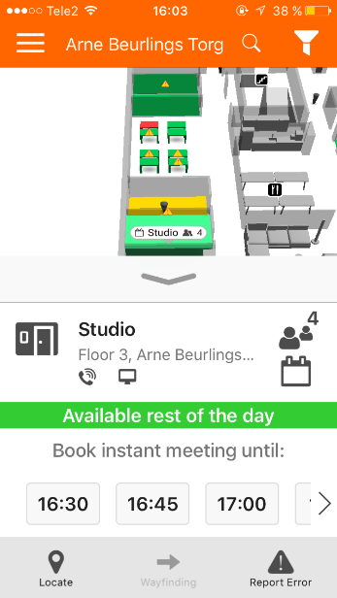
Quick view, room information and calendar.
- “The Bookable icon” indicates that the room is bookable.

At the top, room name, floor and building is written. The equipment is visulized below the name and to the right you see the number of seats and the “bookable sign”. Under the room info comes the simplifyed room calendar which shows for how long the room is free. Press on a time bar to select the end time for the meeting. A manual check-in is then required on the roompanel to confirm that the meeting room will be used.
Wayfinding is also possible from this view, which then will close the quick view window and show the path on the map.
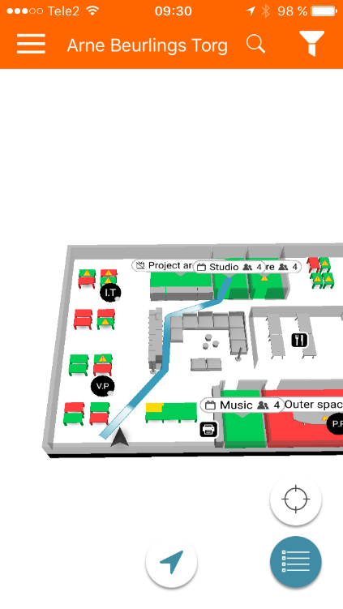
Wayfinding from position to meeting room “Studio”.

